|  |
| --- |
| **Heriot-Watt University** |
| SQUEEZE 8 |
| Version 8.0, March 2013 |

USER’S MANUAL

Oscar Vazquez, Eric Mackay and Ken Sorbie

**TABLE OF CONTENTS**

1 INTRODUCTION TO sqUEEZE 8 4

1.1 Installation of SQUEEZE 8 5

1.2 Updating installed version of SQUEEZE 8 7

1.3 About This Manual 7

2 User interface for data input 7

2.1 Multiple Simulations 8

2.2 Simulation Type 9

2.3 Help Button 9

2.4 About button 9

2.5 Isotherm fitting button 9

2.6 Project title 10

2.7 Controls functionality group 11

2.7.1 Read File 11

2.7.2 Basic Parameters 11

‐ Simulation Type 12

‐ Model type 12

‐ Units 12

‐ Isotherm Derivation Parameters 13

‐ Basic Model Parameters 13

‐ Well Friction 13

‐ Temperature Calculations Parameters 14

2.7.3 Edit Model 14

‐ Layer properties 15

‐ Component Properties 19

‐ Stages Properties 30

‐ Graphics Options 37

2.7.4 Run Model 38

2.7.5 Abort Model 38

2.8 Graphics functionality group 38

2.8.1 Output Frequency 38

2.8.2 GRAPH CROSS 38

2.8.3 GRAPH TIME 39

2.8.4 GRAPH RAD 40

2.9 CLOSE ALL 41

# INTRODUCTION TO sqUEEZE 8

SQUEEZE 8 is a software package for modelling oilfield scale inhibitor squeeze treatments both in laboratory core floods and in the field. SQUEEZE 8 offers significant enhancements to the earlier versions, it provides a wider suite of tools for modelling both field and experimental scale inhibitor squeeze treatments. A wide range of options is available in SQUEEZE 8, where all the previous model are retained in this last version, including Hong and Shuler analytical model, the Isotherm validation and derivation and the 1D coreflood and radial near-well model, although they have been improved in various ways. The most important new facilities and modifications that have been implemented in SQUEEZE 8 are as follows:

1. **Two phase flow**, the simulation of water and oil phase is included, in particular an aqueous and a non-aqueous phase.
2. **Automatic Isotherm History Matching,** Isotherm history matching for a given field return profile may require effort and time, this tool provides an automatic method.
3. **The Data-Input Interface** has been completely re-written in Visual C++ for modifying project input data files. This offers a much more flexible, user-friendly and robust data processing tool.
4. **The Graphical Output** for displaying real-time simulation results has been completely rewritten. This offers a much more flexible, user friendly and robust processing tool.

The flowchart shown in summarises the SQUEEZE 8 models and their functions. The details of operating each specific branch of the program will be introduced in the relevant chapters of this manual.



Figure 1.1 SQUEEZE 8 model overview.

## Installation of SQUEEZE 8

Download the zip file SQUEEZE8_full.zip; this file contains the folder and subfolders necessary to run SQUEEZE. When you extract the files from this zip file to a location of your choice, you should have the folder/subfolder tree structure shown in the illustration below. For SQUEEZE to function correctly you must ensure that the subfolders are located in the same parent folder as the SQUEEZE8

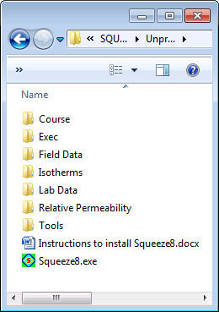

Figure .2 SQUEEZE 8 folder/subfolder tree structures.

A description of the contents and use of each folder can be found below:

1. **Course:** This folder contains the materials for the beginners and advanced courses, including example files, presentations, exercises, useful tools and a selection of papers about squeeze treatment modelling.
2. **Field Data*:**The field return profiles from scale inhibitor squeeze treatments are stored in this folder, which also includes a template “FieldData-Template.txt”.
3. **Exec*:**This folder contains the essential executables.
4. **Isotherms*:**This folder is used to store isotherm tables, which are generally derived from coreflood experiments; a template file “Isotherm-Template.txt” is included in this folder.
5. **Lab Data*:**This is where SI effluent concentration profiles from laboratory from corefloods tests are stored; a template file “LabData-Template.txt” is to be found in this folder.
6. **Relative Permeability*:** Oil and water relative permeability curves in table format are stored in this folder, which includes a template file “RelPerm-Template.txt”.
7. **Tools:**Various tools may be found in this folder, including the necessary files to install the HASP device driver.

***\*Note:*** *All folders with an asterisk are required to allow SQUEEZE to function properly.*

## Updating installed version of SQUEEZE 8

If you have already installed a version of SQUEEZE and would like to install a newer version, it should just be a case of downloading the executables, although depending on how old your last version was you may also need to install the relevant driver for the HASP key. The following steps should be carried out:

1. Replace the executable file “Squeeze8.exe” in the same location.
2. Replace contents of the folder “Exec”.

## About This Manual

In addition to a general discussion of the functions and capabilities of the SQUEEZE 8 models, this manual is intended to be a training manual which aims to take you through the dialogs to build your own model input data files. SQUEEZE 8 input data has been designed as a number of intuitive dialog based modules, where a number of models can be included in the simulation project. Emphasis is placed on the actual physical/chemical problem which is being modelled rather than on a description of the mathematical and numerical details of the SQUEEZE 8.

For further assistance and/or support, please contact:

Oscar Vazquez Oscar.Vazquez@pet.hw.ac.uk +44 131 451 3609

Eric Mackay Eric.Mackay@pet.hw.ac.uk +44 131 451 3670

Heather O’Hara Heather.OHara@pet.hw.ac.uk +44 131 451 4312

# User interface for data input

The SQUEEZE 8 interface is an interactive program for creating, editing or/and modifying SQUEEZE 8 input data files. The interface employs standard Microsoft dialog windows, see Figure 2.1. This is the main dialog which gives the user full access to the all the models to build any project, as well as editing any project, in addition it gives full access to the graphical output. The functionalities are divided in different groups or standalone functionality. Let’s start from top left then right:

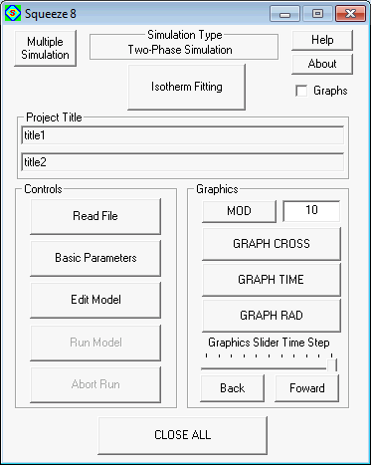

Figure 2.1 The opening page of SQUEEZE V interface

## Multiple Simulations

This button gives the opportunity to simulate automatically any number of projects. This feature is useful for sensitivities studies, where a number of models may have to be simulated. To use this facility the name of the projects should be edited and saved (in Notepad or other text editor), the file should be saved with the extension “inp”, an example is shown in Figure 2.2.

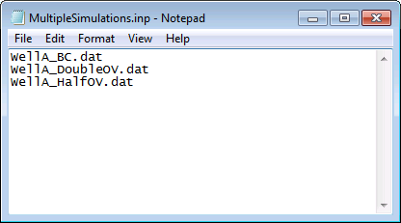

Figure 2.2 Multiple simulations file with “inp” extension.

## Simulation Type

This text box shows the type of simulation for a given project: Single or Two-phase flow, see Figure 1.1 for model overview.

## Help Button

By pressing the “Help” button the manual appears.

## About button

By pressing the “About” button the version of the code will appear. The code is continuously revised and updated. New releases are available to the sponsors through the FAST group website, <http://dscale.org>.

## Isotherm fitting button

The ultimate goal of using the SQUEEZE 8 program is to model, predict and design/improve scale inhibitor downhole squeeze treatments. One possible approach, assuming that no experimental data is available but that we have some field inhibitor return profiles, is to "history match" the return profile and then use it for prediction. Previously, the “history match” process was done manually by trial and error until the adsorption parameters that gives the best fit to the inhibitor return concentration profile. This functionality provides an automatic method. Any old project can be used, when the “Isotherm Fitting” button is pressed a Windows Open File Dialog appears and any project input file can be loaded. Then the “Isotherm Fitting” dialog, Figure 2.3, which shows the different methods for the automatic history matching, this is a very wide area of research, to facilitate its use, and the user may press the “Default button” which defined a set of parameters that seem to work reasonably well.

Once the calculations have finished a window is presented with a number of possible isotherm candidates, see Figure 2.4. This is due to the stochastic and iterative nature of the algorithms, the algorithms are population-based, where each iteration the population is modified, evolving towards the best solutions, in the window the best solutions per generation is shown, giving the user to explore a number of possible solutions, in certain occasions the decision which is the best solution may be subject to interpretation.

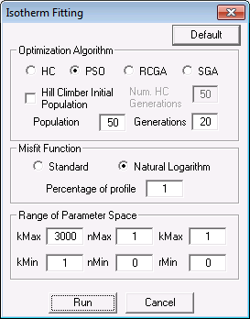

Figure 2.3 Isotherm Fitting Dialog.

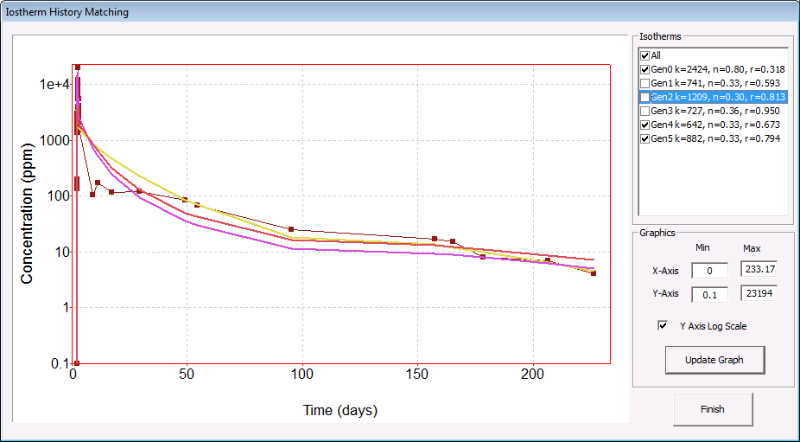

Figure 2.4 Isotherm History Matching Dialog

## Project title

This text box shows the simulation title, normally used to describe the simulation project.

## Controls functionality group

This group box contains the functionalities to open, edit and run simulation projects. This will be described below.

### Read File

It loads an old project simulation model, this version is back compatible with SQUEEZE 5, 6 and 7. The input files data files have “dat” extension.

### Basic Parameters

This functionality determines the basic setting of the simulation project such as among others simulation type, units and Basic Model Parameters, which will be described below. Depending on the simulation type, the model types are available otherwise are greyed-out, then depending on the model type the appropriate functionalities become active, see Figure 2.5.

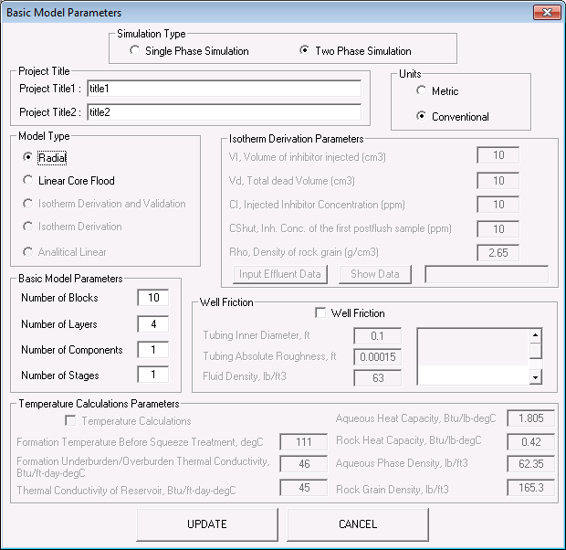

Figure 2.5 Basic Model ParametersDialog.

#### Simulation Type

This is possibly the most important setting as this will determine the models that may be included in the simulation project, refer to Figure 1.1 for a model overview.

#### Model type

The model type depends on the simulation type; refer to Figure 1.1 for model overview. Single phase simulation are as follows:

1. Radial, it simulates field application, simulates are around the wellbore.
2. Linear Coreflood, it simulates a coreflood experiment.
3. Isotherm Derivation and Validation, derives an isotherm for a coreflood and validates it against the return profile.
4. Isotherm Derivation, it derives isotherm from coreflood experiment.
5. Analytical Linear, this presents analytical solution to the one-dimensional (1D) inhibitor transport equation which are valid in certain limits.

And for Two-phase flow simulation:

1. Radial, it simulates field application, simulates are around the wellbore.
2. Linear Coreflood, it simulates a coreflood experiment.

#### Units

Two unit conventions are available, Metric and Conventional units, which are detailed in Table 2.1.

|  |  |  |  |  |
| --- | --- | --- | --- | --- |
|  | | **Conventional** | **Conversion Factor** | **Metric** |
| **Length, height, radius** | | ft | *0.3048 | m |
| **Viscosity** | | cP | * 1 | cP |
| **Volume** | | bbl | * 0.158987295 | m3 |
| **Absolute permeability** | | mD | * 1 | mD |
| **Concentration** | | ppm | * 1 | ppm |
| **Adsorption** | | mg / l of rock | * 1 | mg / l of rock |
| **Stage Type** |  |  |  |  |
| **Injection/Overflush** | **Flow rate** | bbl/min | * 0.158987295 | m3/min |
| **Injection/Overflush** | **Time** | hours | * 1 | hours |
| **Production** | **Flow rate** | bbl/day | * 0.158987295 | m3/day |
| **Production** | **Time** | day | * 1 | day |
| **Shut-in** | **Time** | hours | * 1 | hours |

Table 2.1 Metric and Conventional units convention.

#### Isotherm Derivation Parameters

In this group box the parameters for isotherm derivation are specified:

1. Volume of Inhibitor injected
2. Total dead volume
3. Injected Inhibitor Concentration
4. Inhibitor Concentration of the first postflush sample
5. Rock Density
6. Effluent Data

#### Basic Model Parameters

In this group box, the following basic parameters to run a given simulation:

1. Number of Blocks: Define the number of grid blocks to be used in the simulation and their sizes. More grid blocks will produce more accurate results, but will require more time to perform the calculations, see Figure 2.6

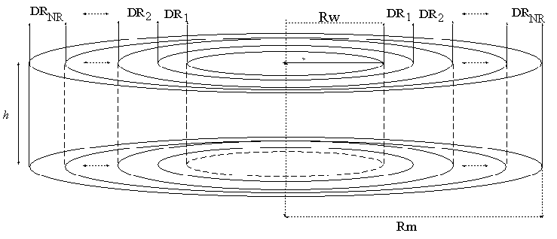

Figure 2.6 Grid well dimensions - Wellbore Radius (Rw) and the Maximus Radius (Rm).

1. Number of Layers
2. Number of Components: In Single Phase simulation type only one component is allowed, whereas in two phase any number, thus you could explore the effect of a viscosifying agent in the squeeze lifetime, as an example. Any combination is allowed, surfactant plus visocosifier plus bridging agent if desired.
3. Number of Stages

#### Well Friction

This model is only available for Two-phase flow simulation type and simulates the frictional pressure drop due to tubbung roughness. This is kind of phenomena occurs generally in long horizontal wells. For preliminary calculations it is advisable to use the defaults values for the tubbing inner diameter, fluid density and tuning absolute roughness.

#### Temperature Calculations Parameters

The temperature calculations is only available for Single Phase if precipitation is chosen, where the parameters necessary are as follows:

1. Formation Temperature before squeeze treatment
2. Formation Underburden/Overburden Thermal Conductivity
3. Thermal Conductivity of Reservoir
4. Aqueous Heat Capacity
5. Rock Heat Capacity
6. Aqueous Phase Density
7. Rock Grain Density

### Edit Model

When the user presses this button, a new dialog appears where the layers, components, stages and graphics options are determined, see Figure 2.7.

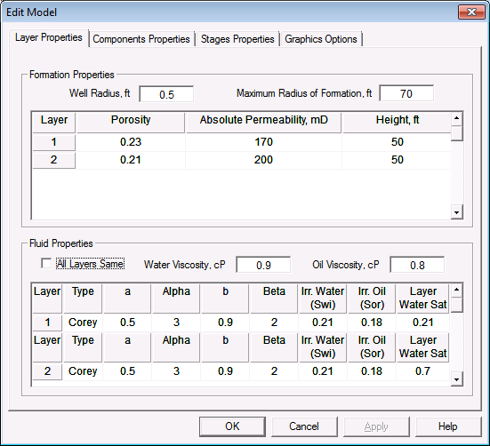

Figure 2.7 Edit Model Dialog

#### Layer properties

The first tab in the dialog is the layer properties, depending on the simulation type, certain information is required, if it is not it will be greyed out. The top part of the window is where the formation properties are determined, where we differentiate between Radial Model (Field case) and linear coreflood, which is common for single and two phase simulation.

##### Formation Properties in Radial Model:

To fully describe the formation properties around the well bore are the well radius and the maximum radius of formation, Rad. Max, see Figure 2.8, which can be set somewhat beyond the penetration of the injected fluid volume, including preflush, inhibitor and overflush. This can be calculated using Excel based tool, in the Tools directory or downloadable from dsale.org, slug-depth.xls. The number of layers is set in the Basi Parameters dialog, for multilayer system porosity, height and permeability is necessary. For single layer, permeability is not necessary as it used to calculate flow distribution.



Figure 2.8 Radial Model Formation properties (Field case).

##### Formation Properties in Linear Core-flood properties:

This model extends the linear 1D equations described by Hong and Shuler (1988) to describe both equilibrium and non-equilibrium inhibitor adsorption squeeze treatments at the laboratory core scale. To fully describe the system length, core diameter and porosity needs to be set.

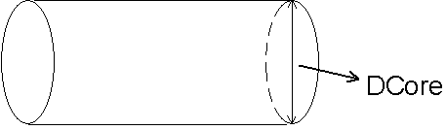

Figure 2.9 Linear Coreflood Model Formation properties (Field case).

##### Fluid Properties

Fluid properties have to be defined when two-phase flow simulation is selected, see Figure 2.10.. The simultaneous flow of two immiscible fluids is determined by their viscosities and the relative permeability curves. The fluids are considered to incompressible, so at any given time and location the addition of both saturations has to be 1 (or 100%).

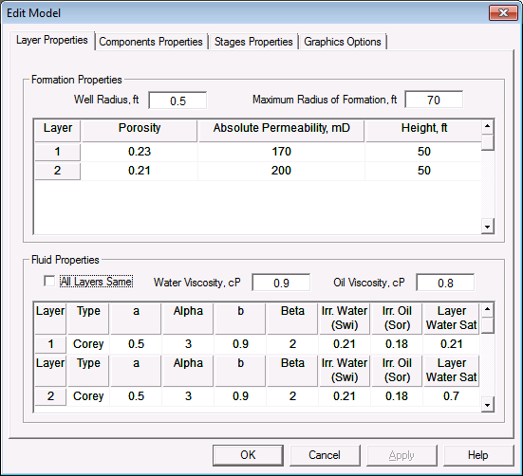

Figure 2.10 Fluid Properties (Two-Phase simulation).

The relative permeability curves may be defined by the Corey constants (a,) for water and (b,), see Figure 2.11, where *Swi* is the irreducible water saturation and *Sro* is the residual oil saturation, or as a table consisting of three columns, the water saturation, the water and oil relative permeability values, see Figure 2.12. Any new relative permeability table should be in the “Relative Permeability” folder using the given format.

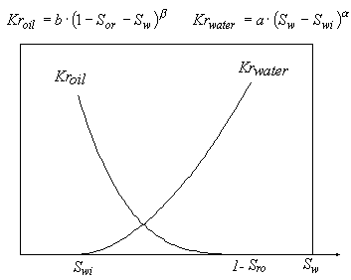

Figure 2.11 Corey Relative Permeability curves.

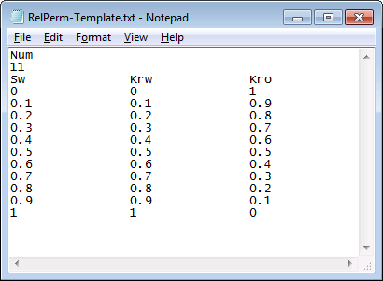

Figure .12 Relative Permeability Table.

Finally, to fully describe the system the initial water saturation per layer has to be specified. This can be calculated from the water cut at the time of the treatment. See Figure 2.13below an example; imagine the relative permeability curves are defined by the Corey constants or the table which are equivalent, see Figure 2.13. To calculate the water fractional flow, which is equivalent to water cut, we use the equation below. AS you can see the water fraction flow is function of the water saturation. Figure 2.14 shows graphically the estimated water saturation at 50% water cut, which gives an approximate initial water saturation of 0.56 (or 56%). This file “RelPerm.xls” can be found in the “Relative Permeability” folder or downloadable from “dscale.org”.

$$Water Cut=f_{w}(S_{w})=\frac{1}{1+\frac{{μ_{w}∙k}_{ro}(S_{w})}{{μ_{o}∙k}_{rw}(S_{w})}}$$

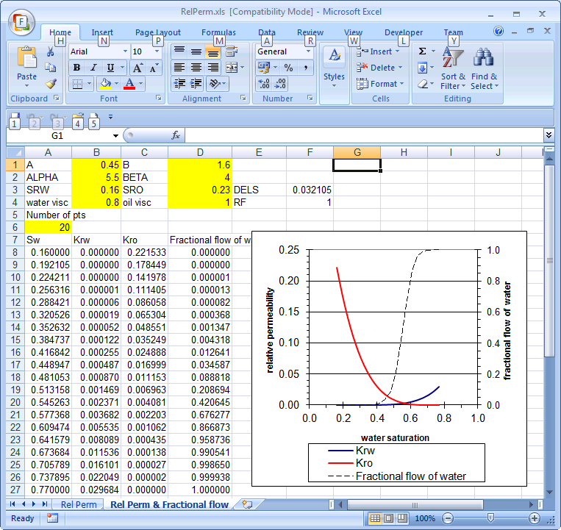

Figure .13 Relative Permeability Curves and Fractional Flow.



Figure .14 Water saturation estimation from water cut.

#### Component Properties

This dialog requires different data for single or two phase simulation as shown below, where the scale inhibitor retention, and in two-phase flow simulation, the user can determined the role of a number of components, in single-phase only scale inhibitor is allowed.

##### Same all layers:

If this box is ticked all the layers have the same component properties for single and two-phase simulations.

##### Single Phase Simulation Dialog:

In Single-Phase simulations, there a two possible models to simulate the scale inhibitor that can layer dependent, as shown in Figure 2.15, precipitation or adsorption:

1. Precipitation: The dynamic behaviour of a precipitation system is assumed to be governed by the inhibitor solubility and the rate of precipitation/dissolution. The user has to input the critical temperature, Cr.Temp, Cps1 inhibitor precipitation solubility at temperature equal to or above the Cr.Temp, Cps2 inhibitor precipitation solubility at temperature below the Cr.Temp.
2. Adsorption: The dynamic behaviour of an adsorption system is determined by the adsorption isotherm. The user has to input the isotherm form that can be taken as Freunlich, Langmuir or table of numbers. The adsorption process may be at equilibrium or non-equilibrium, where a adsorption rate is required.

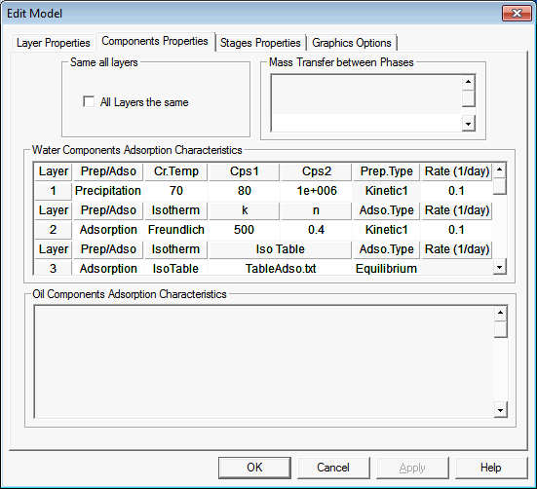

Figure .15 Single Phase Component Properties

##### Two-Phase Simulation Dialog:

There are a number of fundamental differences between single and two-phase simulation. In two-phase simulations mass transfer is allowed between phases, as well as there is no restriction in the number of components, which can have different roles. As before, each layer may have different roles with different properties.

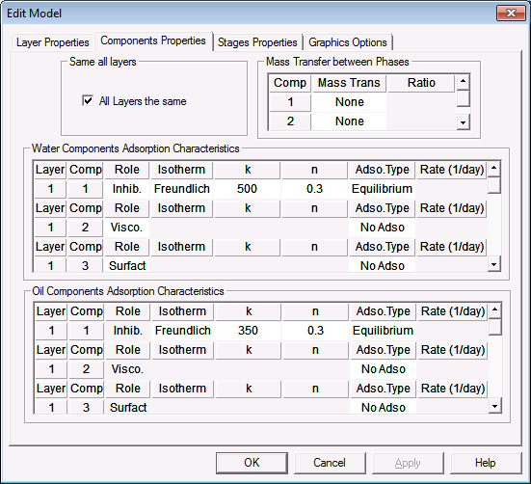

Figure .16 Two-Phase Component Properties.

###### Mass transfer between layers:

The user defines for a given component if it may be partitioned between the water and the oil phases. The mass transfer between oil and water phase is given by a proportionality constant *kow*, which gives the proportion of the concentration in the oil and the water phase, as follows:

$$k_{ow}=\frac{C_{o}}{C_{w}}$$

###### Component Role:

1. Tracer: An inert chemical agent, which neither adsorbs onto the rock surface nor is transferred between phases.
2. Inhibitor: A chemical agent that may adsorb onto the rock surface and may be transferred between phases.
3. Viscosifier: A chemical agent that in solution which may increase the viscosity of the solvent (water phase). In addition, it may also adsorb onto the rock surface and may be transferred between phases. The user is required to enter information about the static viscosity and flowing viscosity:

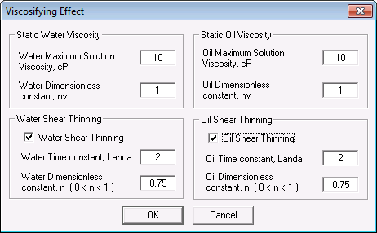

Figure .17 Viscosifier Model Dialog.

* 1. Static Viscosity: At a fixed shear rate, the viscosifier solution viscosity is a function of polymer concentration, as shown schematically in the figure and described by the equation below, where  is the polymer solution viscosity, *Max* is the maximum viscosifier solution viscosity, and C and C*Max* are the actual and the maximum viscosifier concentration in solution, respectively and is a dimensionless constant, see Figure 2.18.

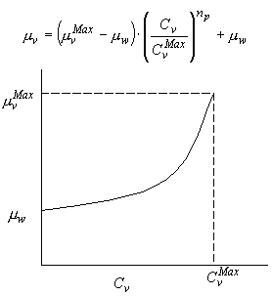

Figure .18 Static viscosity model.

* 1. Flowing viscosity: The solution viscosity under flowing conditions for a given shear rate may be described by the Carreau model, as given in the equation below and figure below, see Figure 2.19, where  is the shear rate, □ is zero shear rate viscosity,  is the infinite shear rate viscosity - usually taken as the solvent viscosity,  is a time constant and *n* is a dimensionless constant, 0*< n<* 1 (*n =* 1 for Newtonian fluids).

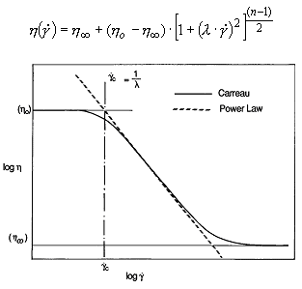

Figure .19 Flowing viscosity Carreau Model.

The shear for phase *p* is calculated with the following equations,, velocity for phase *p* and , equivalent radius.

1. Surfactant: Chemical agent that reduces water and oil residual saturation
   1. Reduction of residual water and oil saturation:

The residual water and oil saturations are the saturations at which the phase relative permeabilities are zero, thus making them immobile. This immobility is due to the fact that the water/oil pressure alone is not enough to overcome the relatively higher capillary pressure of the oil/water in the smaller pores.

A surfactant offers the possibility of making these saturations mobile by reducing the oil-water surface tension and thereby reducing the capillary pressure. The effect of the surfactant is modelled through the modification of the relative permeability curves, which are intrinsically linked to the capillary pressures, even if the capillary pressures are not explicitly modelled. Essentially there is a transition between the immiscible (or initial) relative permeability curves related to the original high capillary pressure, and the miscible relative permeability curves related to low capillary pressure. The procedure for applying the surfactant model in SQUEEZE8 is described below.

***Step 1:*** Calculate the new residual water () and oil () saturation as a function of the Surfactant concentration, .

, 

where ,  and  are the residual water and oil at maximum Surfactant concentration,  and , are the Surfactant concentrations in the water and oil phases, since the surfactant may partition between the water and oil phases.

***Step 2:*** Calculate the new value of the water and oil relative permeabilities as functions of the Surfactant concentration, as follows:

New Water Relative Permeability value at a given water saturation:



where  is the miscible water relative permeability curve,  is the immiscible (or initial ) water relative permeability curve and  is the weight between this two values, values calculated as follows:

,where

Figure 2. shows the initial (*Krw*), miscible (*Krw* *Misc*) and transition (*Krw* *Trans*) water relative permeability curves.



Figure .1 Calculation of the water relative permeability.

New Oil Relative Permeability value at a given water saturation:



where  is the miscible water relative permeability curve,  is the immiscible (or initial ) water relative permeability curve and  is the weight between this two values, values calculated as follows:

,where 

Figure 2.20 shows the initial (*Kro*), miscible (*Kro* *Misc*) and transition (*Kro* *Trans*) oil relative permeability curves.



Figure .20 Calculation of the oil relative permeability.

* 1. Alteration of scale inhibitor adsorption:

It is known that inhibitors adsorb less well on hydrophobic surfaces such as those which are present on oil wetted minerals, previous work has shown that quite often clays are wetted by oil. Since clay minerals in a water wet state are the highest absorbers, a change of wettability induced by certain surfactants may enhance scale inhibitor adsorption, and so the treatment lifetime. Furthermore, as shown above, the surfactant reduces the residual water and oil saturation, hence augmenting the rock surface available for adsorption. Thus, the SI adsorption alteration is modelled as a function of the augmented rock surface; we use the new residual oil saturation (or augmented water saturation) as the factor that determines it, see Figure 2.21. Assuming high SI adsorption at minimum residual water saturation (*Adso Surf*) and an initial SI adsorption at initial residual water saturation (*Adso No Surf*), where the actual SI adsorption is calculated as an interpolation of both isotherms, as shown below:



where  is the actual adsorption,  is the new adsorption at maximum Surfactant concentration,  is the initial adsorption at zero Surfactant concentration and  are the residual water and oil at maximum Surfactant concentration, .



Figure .21 SI adsorption isotherm based on the surfactant effect, where *Adso* is the actual adsorption due to the Surfactant, *Adso Surf* is the new adsorption at maximum Surfactant concentration and *Adso No Surf* is initial adsorption at zero Surfactant concentration.

1. Blocker: Chemical agent that may reduce the formation permeability due to adsorption, which may transfer between phases. Although this type of chemicals is used for water cut treatments, there have been some proposals to use combined treatments.

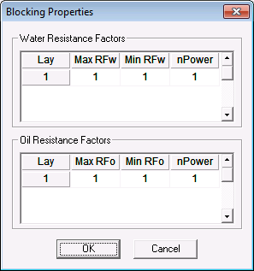

Figure .22 Blocker Model Dialog.

The permeability reduction is modelled by the application of resistance factors to water and oil flow, which are denoted *RF*w and *RF*o , see Figure 2.22, respectively, as shown in Figure 2.23.

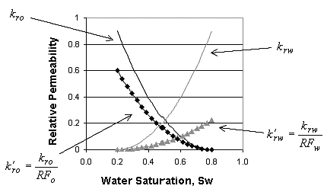

Figure .23 Resistant Factor Model.

To calculate *RF*w and *RF*o, the variable resistance factor method is used, see , based on the blocker adsorption level (the higher the blocker adsorption level the greater the layer thickness and hence the greater is the permeability reduction), as shown in the figure below:

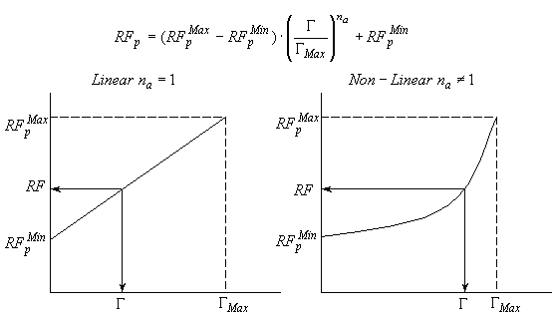

Figure .24 Variable Resistance Factor Method

1. Bridging agent: This model simulates the enhancement of Scale Inhibitor retention. Various techniques have been previously proposed such as inducing additional precipitation, injection of surfactant and amphiphilic system to increase rock surface, creation of more positively charged rock surface, incorporating cationic monomer into the structure of the polymeric inhibitor, use of cross-linked scale inhibitor and use of kaolinite for enhanced SI adsorption.
   1. Enhanced Scale Inhibitor Adsorption Models: Based on the published literature about additive packages for SI enhanced adsorption and the different techniques proposed, it is envisaged that the SI additional adsorption will depend on the additive adsorption level. It is also assumed that there is a maximum level of the additive, $Γ_{add, max}$, beyond which further SI adsorption enhancement will not occur, which is assumed to occur at the maximum additive adsorption level, which will provide maximum enhanced SI adsorption effect. The model to calculate the degree of SI adsorption enhancement is illustrated in Figure 2.25. Figure 2.25 a) and b) show the hypothetical isotherms for SI ($Γ_{SI}^{*}$ = non-enhanced and $Γ_{SI}^{**}$ = maximum enhanced) and the additive adsorption isotherm, $Γ_{add}$, respectively. The model calculates the non-enhanced SI adsorption level, $Γ_{SI }\left(C_{SI}\right)$, the highest possible SI adsorption, $Γ_{SI}^{**}\left(C_{SI}\right)$,and the adsorption of the additive, $Γ_{add }\left(C_{add}\right)$. Then by linear interpolation as function of the additive adsorption level, the actual adsorption level of SI, $Γ_{SI}^{*}$, is calculated using equation (1), which is graphically represented by Figure 2.25 c.

$$Γ_{SI}^{*}\left(C_{SI}\right)=Γ_{SI }\left(C_{SI}\right)+\left(Γ_{SI}^{**}\left(C_{SI}\right)-Γ_{SI }\left(C_{SI}\right)\right)⋅\frac{Γ_{add }\left(C_{add}\right)}{Γ_{add, max}}$$

c)

$$Γ_{SI}^{Max}$$

$$Γ_{add}^{Max}$$

$$Γ ({mg}/g)$$

$$Γ_{SI}^{No Add}$$

$$Γ_{add}^{1}$$

$$Γ_{add}^{2}$$

$$Γ_{SI}^{2}$$

$$Γ_{SI}^{1}$$

b)

$$Γ_{add}$$

$C_{add}$ (ppm)

$$Γ ({mg}/g)$$

a)

$$Γ_{SI}^{**}$$

$$Γ_{SI}$$

$C_{SI}$ ((ppm)

$$Γ ({mg}/g)$$

Figure .25 Scheme to calculate a degree of SI adsorption enhancement

#### Stages Properties

This dialog requires different data for single or two phase simulation as shown below, which is where every stage is define such as the type of stage injection or production, component concentration, flow rate, volume or time and time step. In addition, the injection and production controls are determined, including flow rate distribution, where any layer may be opened or closed at any stage. There are some differences between single and two-phase simulations

##### Single Phase Simulation Dialog

Figure 2.16 shows the input data dialog, where the properties of each stage can be determined.

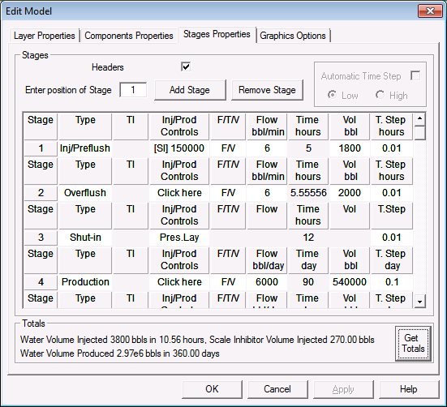

Figure .26 Single-Phase Stages Properties.

###### Add/Remove stage:

The user can add or remove any stage at any position. This facility is especially useful if a new stage was to included in an old design.

###### Headers

The user can remove the stages headers.

###### Stage type:

There mainly two types of stage injection and production. Within an injection stage, it is possible to differentiate between Injection/ Preflush, and Overflush.

1. Injection/Preflush: Stage where the chemical is injected at low concentration as a preflush or at working concentrations as a main slug.
2. Overflush: The overflush is at zero chemical concentration, therefore is an injection stage with zero scale inhibitor concentration.
3. Shut-in: Stage while the well is producing or being under injection, this stage allows chemical to adsorb.
4. Production: The well is back in production.

###### Initial Formation Temperature, TI:

This data is required for temperature calculations necessary for precipitation calculations.

###### Injection/Production Controls, Inj/Prod Controls:

This dialog enables the user to determine a number of properties such as the flow rate distribution and the component concentration in Injection/Preflush stages.

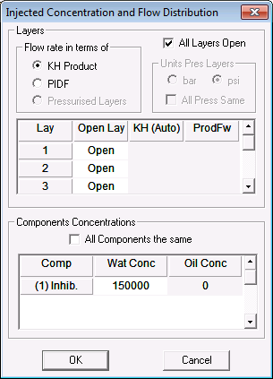

Figure .27 Single-Phase Injection/Production Controls Dialog.

1. All Layers Open:

By setting this control, all the layers are ser to be open

1. Flow Rate in terms of:

If the flow distribution is known, then this can input by selecting *PIDf*. If it is not know then it can be calculated the fluid is distributed according to the *kH* fraction, as shown in the equation below, where *H* is the layer height and *keff* refers to the effective permeability of the layer:

$$Q_{w}\left(i\right)=\frac{H\left(i\right)∙k_{eff}\left(i\right)}{\sum_{all-active-layers}{\left(H∙k_{eff}\right)}}∙Q_{T}$$

1. Initial Components Concentrations:

The user has only to input the component concentration in the water phase.

###### Flow/Time/Volumes, F/T/V:

The user needs to input two of the following Flow rate, Time or Volume, the third is calculated automatically.

###### Time Step, T.Step:

In single phase calculations, the user needs to input this value.

###### Get Totals:

Get the total injected volume of water, scale inhibitor and produced water.

##### Two-Phase Simulation Dialog

Figure 2.17 shows the input data dialog, where the properties of each stage can be determined.

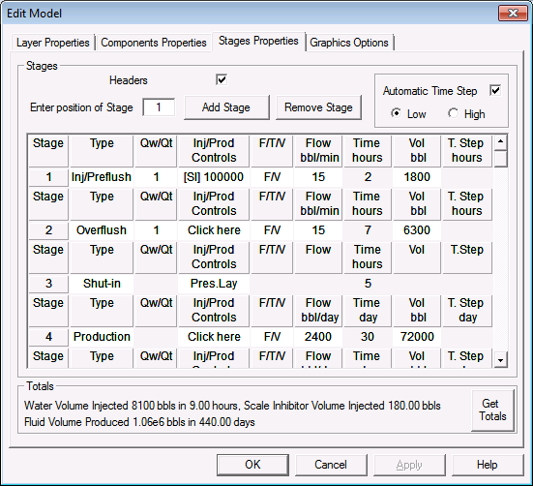

Figure .28 Two-Phase Stages Properties.

###### Add/Remove stage:

The user can add or remove any stage at any position. This facility is especially useful if a new stage was to included in an old design.

###### Headers

The user can remove the stages headers.

###### Stage type:

There mainly two types of stage injection and production. Within an injection stage, it is possible to differentiate between Injection/ Preflush, and Overflush.

1. Injection/Preflush: Stage where the chemical is injected at low concentration as a preflush or at working concentrations as a main slug.
2. Overflush: The overflush is at zero chemical concentration, therefore is an injection stage with zero scale inhibitor concentration.
3. Shut-in: Stage while the well is producing or being under injection, this stage allows chemical to adsorb.
4. Production: The well is back in production.

###### Injection water flow rate fraction, Qwt/Qt:

In two-phase flow simulations the water fraction of the injected water is set. For instance, if an emulsion is injected with 20% water content, then *Qwt/Qt* should be set to 0.2, (1 implies 100% water and 0 100% oil).

###### Injection/Production Controls, Inj/Prod Controls:

This dialog enables the user to determine a number of properties such as the flow rate distribution and the component concentration in Injection/Preflush stages. Notice that to have the effect of any component, being viscosifier, blocker, etc, the injection concentration has to be set.

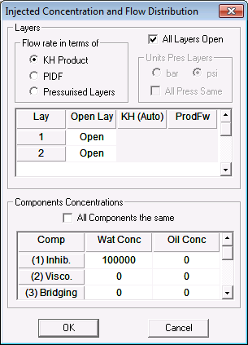

Figure .29 Single-Phase Injection/Production Controls Dialog.

1. All Layers Open:

By setting this control, all the layers are ser to be open

1. Flow Rate in terms of, there three options:
   1. If the flow distribution is known, then this can input by selecting *PIDf*.
   2. If it is not know then it can be calculated the fluid is distributed according to the *kH* fraction, as shown in the equation below, where *H* is the layer height and *keff* refers to the effective permeability of the layer:
 $$Q_{w}\left(i\right)=\frac{H\left(i\right)∙k_{eff}\left(i\right)}{\sum_{all-active-layers}{\left(H∙k_{eff}\right)}}∙Q_{T}$$

  3. Pressurised layers: If the layer pressure is known, then they can be added to calculate the flow distribution. In this version, crossflow in the well bore is not simulated.
   4. ProdFw: It can be thought as the water cut at maximum radius of formation, which normally is assumed to be the same than the well water cut, since it seems reasonable that the amount of water flowing to the well will be very similar few feet in the formation. It only applies to production stages. Its value ranges between 0 and 1 and it can be different for each layer. Figure 2.30 and the equation below illustrate the role of on determining the flow of water in each layer, in terms of the total flow rate, Qwi , i = 1, 2.

C:\Users\oscar vazquez\Desktop\SQUEEZE7\Manual\Pictures\ProductionalFlowEquation.bmp

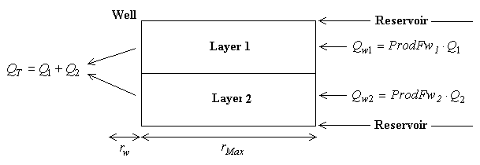

Figure .30 Two-phase flow boundary conditions at production.

1. Initial Components Concentrations:

The user has only to input the component concentration in the water or oil phase.

###### Flow/Time/Volumes, F/T/V:

The user needs to input two of the following Flow rate, Time or Volume, the third is calculated automatically.

###### Time Step, T.Step:

The time step can be automatically calculated to guaranty numerical stability.

###### Get Totals:

Get the total injected volume of water, scale inhibitor and produced water.

#### Graphics Options

The graphic options are slightly different for Single, see Figure 2.31 and Two-Phase flow simulations, see Figure 2.32. The most important features are the following:

1. Inhibitor concentration for colour shading, see Figure 2.34 right hand side graph.
2. Report up to five squeeze lifetimes at different MICs.
3. Include field data
4. Plot up to 8 previous run, extremely useful to analysis sensitivity calculations.

##### Single Phase Flow Simulation

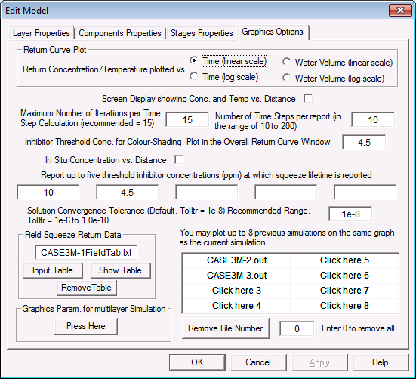

Figure .31 Single-Phase Flow Graphics Options Dialog

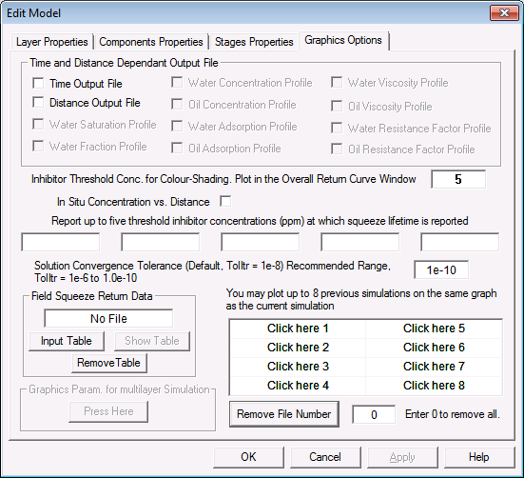

Figure .32 Two-Phase Flow Graphics Options Dialog

### Run Model

It starts the simulation and creates an output file with extension "out".

### Abort Model

It aborts the simulation at any time; the information is saved till the abortion.

## Graphics functionality group

This group box contains enable the user to navigate through a number of graphs, which is designed to be a postprocessor. Once the simulation is run the user can use the “Graphics Slider Time Step” to navigate through the reported time steps. The functionalities will be described below.

### Output Frequency

Only for two-phase flow simulation, set the number of time steps per report.

### GRAPH CROSS

In situinhibitor concentration field in the near-well formation is displayed along the radial distance from the wellbore. Seven colours are used to represent different concentration intervals. The grid is proportional to the grid block sizes used in the numerical simulation. This graph is very useful to analysis placement or which layers have been depleted of scale inhibitor, see Figure 2.33.

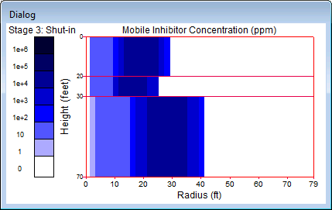

Figure .33 The window for the in situ inhibitor properties for the multi-layer radial model.

### GRAPH TIME

There are two graphs that are activated with this control. Figure 2.34 shows the scale inhibitor overall return concentration is displayed. If there are any measured field inhibitor squeeze return data, these data points also can be (optionally) displayed on the screen. If you have outputs from your previous simulation runs for the same treatment (e.g. with different adsorption isotherm parameters), the return curves for the previous runs can also be displayed along with the currently modeled inhibitor returns. The colour bar appearing on the rightmost side of Figure 2.34, shows the wellbore 'status', i.e., whether the local wellbore block concentration is below, equal to or above a user-specified MIC (GrafMic) as follows:

1. Red colour signals a wellbore block concentration that is below the MIC(GrafMic);
2. Green colour is for concentration greater than the MIC (GrafMic); and
3. Yellow colour is for concentration around the MIC (GrafMic).

Thus, the red colour is an alarm signal for possible scaling problem around that well perforation, the green means OK and yellow is moderate.

The overall inhibitor return curve can be depicted in two ways: the well top inhibitor concentration, *C*, vs. the treatment time, *t*, or *C* vs. the cumulative water volume (including preflush, injection, overflush and produced water volume). The legends (i.e., line style and colour) are chosen to clearly differentiate the various pieces of information which are displayed on the screen. These legends apply to all types of simulations which are described below:

1. Modelled inhibitor return curve, temperature - *blue solid line*,
2. Modelled inhibitor return curve(s) from the previous run(s) - *green, pink, or other coloured solid line*,
3. Measured field squeeze return data or core flood effluent data - *red squares*.

Figure 2.35 displays an example layer return graphics on completion of the simulation. It shows the simulated inhibitor returns for three layers. The horizontal axis of the figure represents either the time or the total water production volume which is the same as that in the overall return curve.

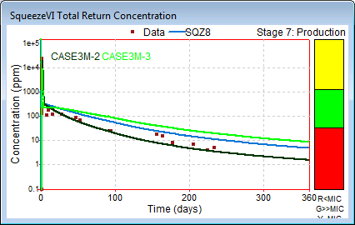

Figure .34 The overall return curve window for the multi-layer radial model.

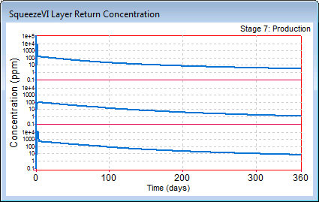

Figure .35 The window for the layer inhibitor returns for the multi-layer radial model.

### GRAPH RAD

Adsorption and Concentration normalised against the maximum adsorption and concentration respectively, see Figure 2.36; and temperature (single-phase) and water saturation (two-phase) along the radial distance for chosen layers, see Figure 2.37.

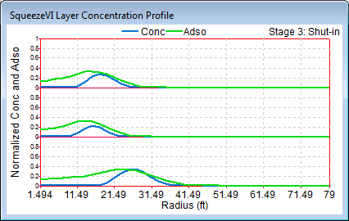

Figure .36 Adsorbed and concentration scale inhibitor for the multi-layer radial model.

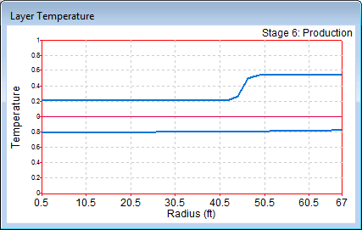

Figure .37 Water saturation for the multi-layer radial model.

## CLOSE ALL

This functionality closes all the graphs and the main dialog.